In this assignment you will create user permissions on a SharePoint site

**Download file and add printscreens. You will submit this file.

Users and Groups

Use the **Contoso site collection** -

1. Create the following ad users in AD

* + 1. carl
    2. cathy
    3. umberto  
         
       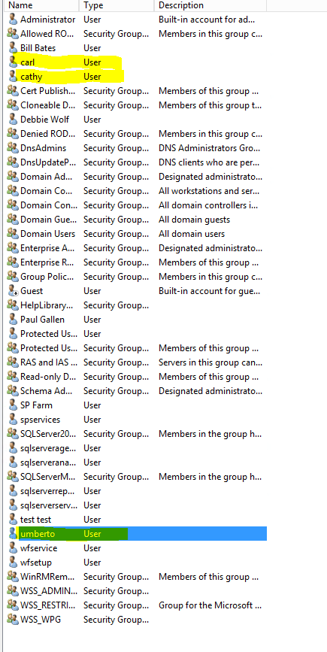

2.    Create the following AD groups

* + 1. research
    2. support  
         
       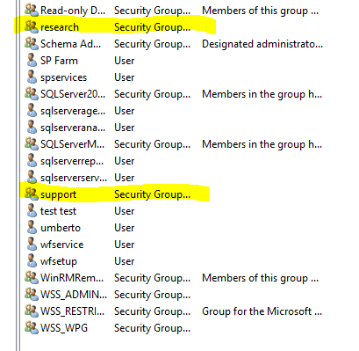

3.    Add carl and cathy to research and umberto to support   
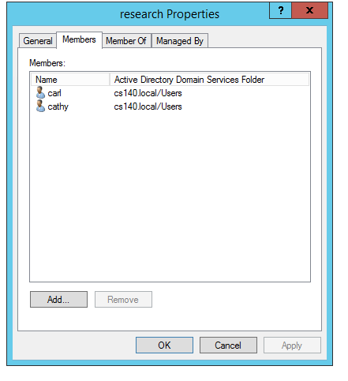  
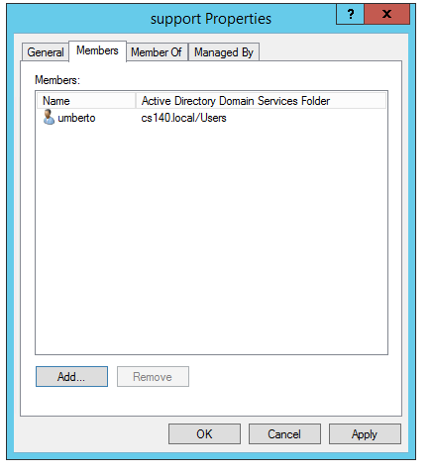

4.    Can umberto log into SharePoint? Why not?

|  |
| --- |
| Since umbero is a member of AD does not mean he is a member of the SharePoint Site. Must be given a shared link or email to be able to join to the team site. |

5.    Create a site in your main Contoso Portal named Research   
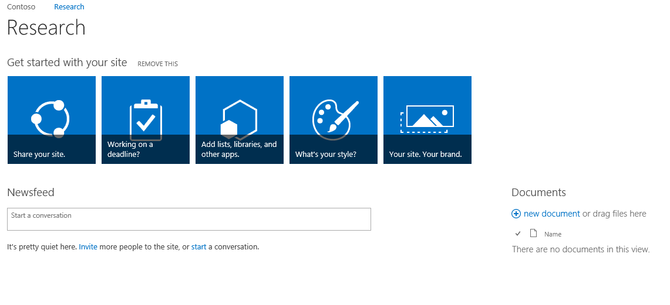

6.    Give umberto access to your portal. He and anyone in support should only be   
 allowed to read and view information at the portal home (top level site).  
  
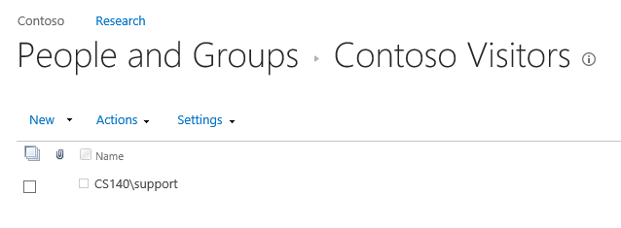  
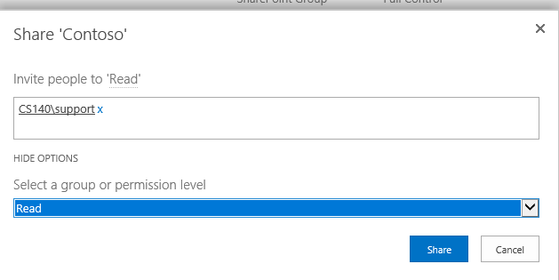  
In the subsite   
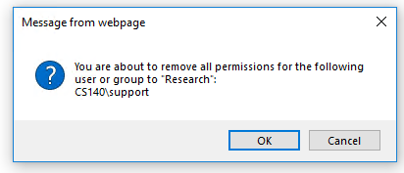

7. Can umberto access the Research site. Why? Why not? 

|  |
| --- |
| Umberto can not even see the research site, so it is safe from the support eyes. |

8. Can carl log into SharePoint? Why not?

|  |
| --- |
| Carl or he/she’s group needs to be added before he/she’s has access to the site collection portal. |

9.    You only want the research group to access the research site. What would you do to   
 provide access only to the research group? 

|  |
| --- |
| What needs to be done is to delete the Admin, and Debbie Wolf owners, but since the two accounts are admins they should not be removed. The account is as secure as it can be without the support accessing the page. |

10. Allow carl and cathy to access (**add content to**) the Research site and only view on the top level site. BBates will need full access to the Research site. What was your process?

|  |
| --- |
| Top level site gave the research and bbates the visitor group    At the research site gave bbates the owner, and research the member permissions |

11.  Test your site

a. carl

carl can contribute and add documents, but not add subsites or other owner level items.

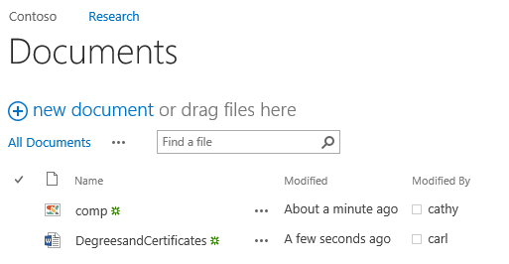

1. cathy

cathy has the same level of permissions as carl does, and could login and add a different document just the same way

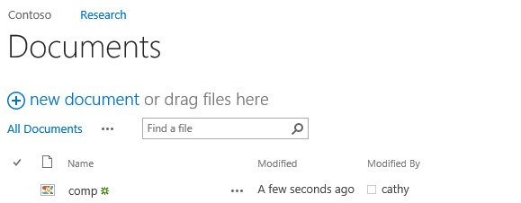

1. bbates

Bill Bates has owner because of the ability to add more sites, and the other researchers did not even have the option to add a subsite

